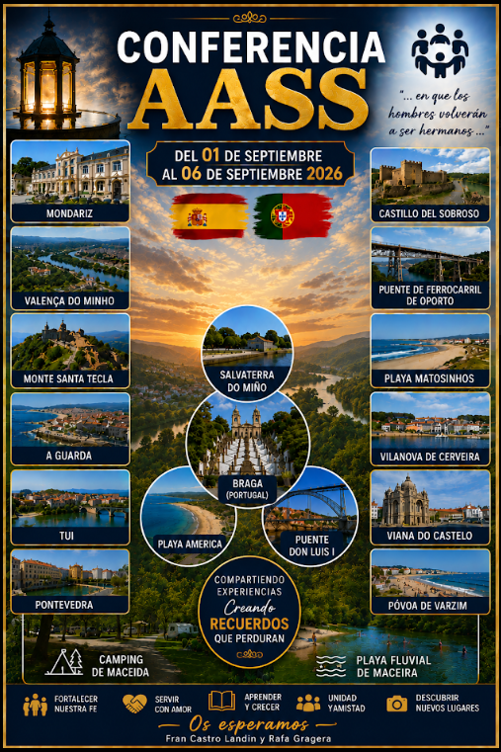
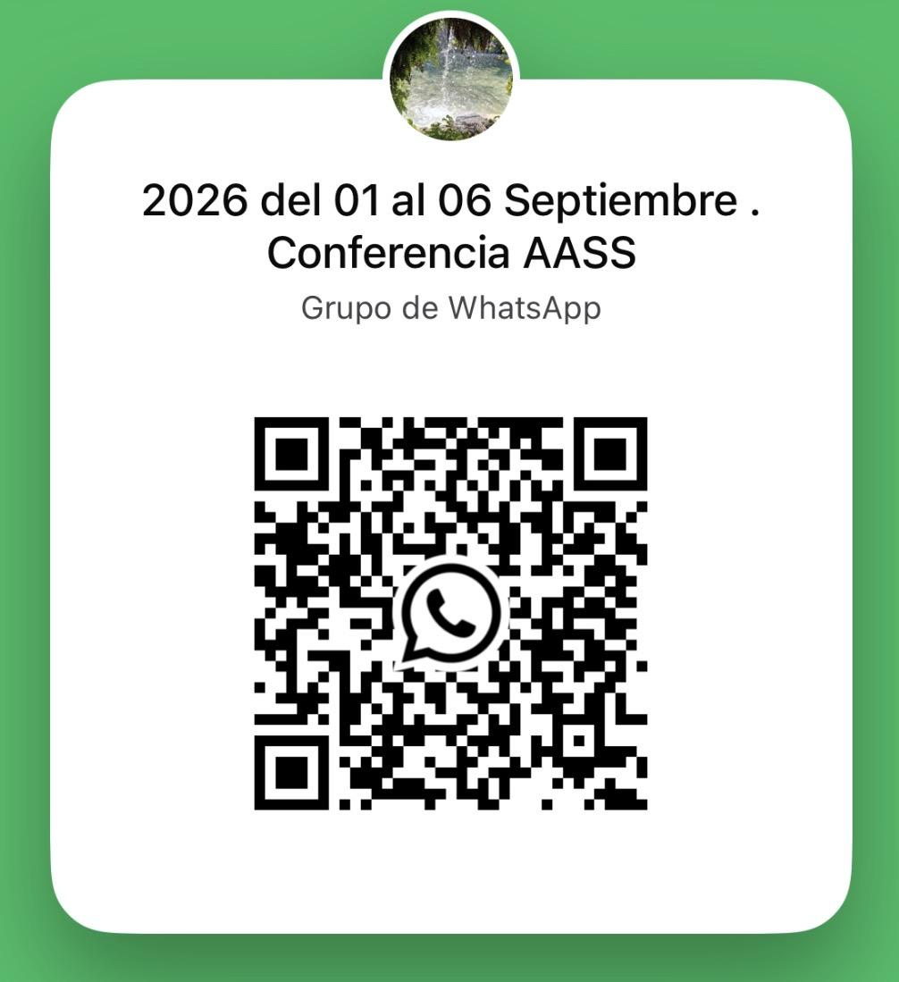
Organizers of this AASS CONFERENCE: WhatsApp Group for this Conference
- Fran Castro Landin +34 646173994
- Rafael Gragera +34 657600663

AASS Assistants:Euros
- José Manuel Tuimil +34 639576145 Local Leader
- Abelardo Rodríguez +34 617066153 Tour Guide
- Mari Fe Yañez +34 647816077 Medieval Costume Advisor
- David Aguilera +34 619079918 Medieval Costume Advisor

In addition to visiting incredible and very popular tourist spots, we’ll enjoy the Feira Franca (Medieval Fair) in Pontevedra and its spectacular tournament...👉 .Check out the Pontevedra Medieval Fair
To really immerse yourselves in the atmosphere, we encourage everyone to put together their own medieval costume (it’s not mandatory, but it adds to the experience!). Here are some ideas to inspire you: 👉Ideas for making your costume
There are also advisors who can help you with your costumes.

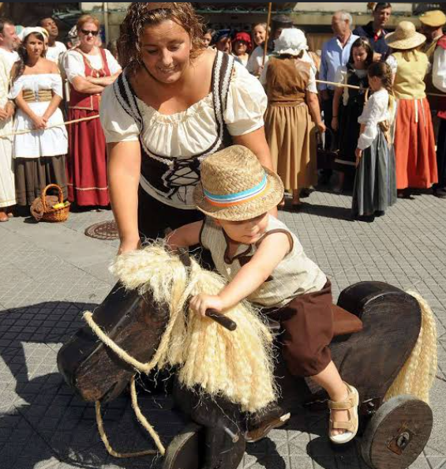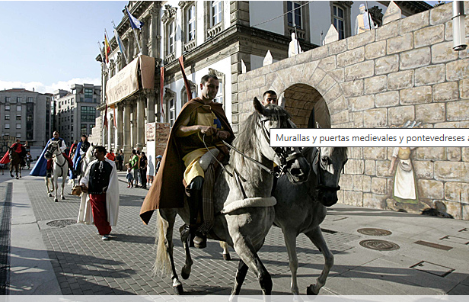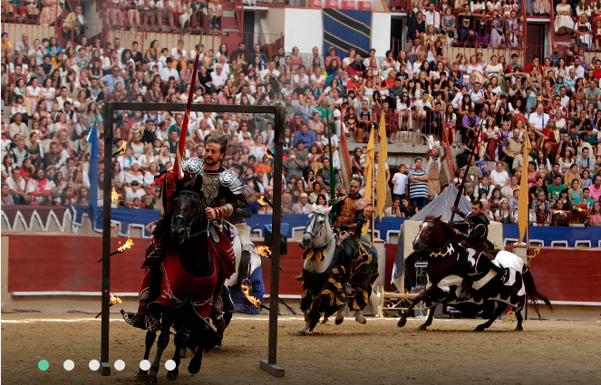

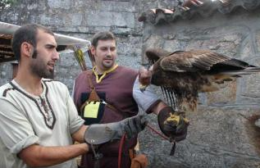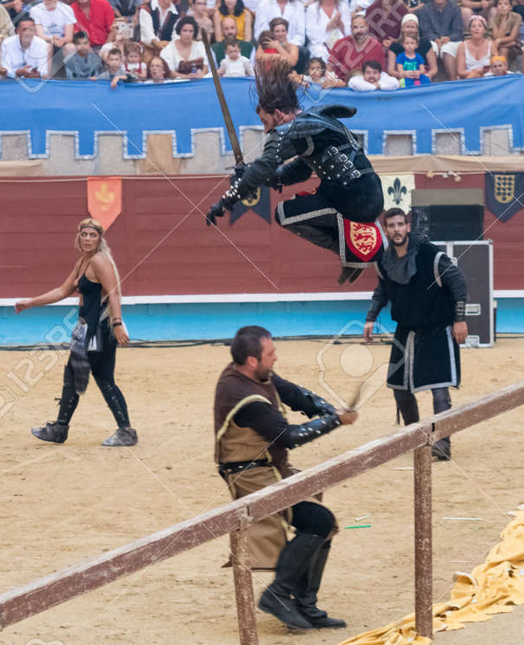

_______________________________________________________________________

Things to Bring:
• Comfortable shoes, flip-flops, and dress shoes.
• Comfortable clothing, dress clothes, a swimsuit, and a shower cap (if you plan to visit the spa).
• Money for meals. Personal items.
• Materials for spiritual study.
_____________________________________________________________________

Where are we going to stay? And what kind of lodging is it?
- Maceira Campground
  - https://www.campingmaceira.com/
https://www.campingmaceira.com/?Zone=Map
- Accommodation options:
  - Bungalow accommodations are sold out, but there are still spots available for camping.
  - Camping site; participants must bring their own tent ⛺ and all necessary gear. See photos at the link https://www.campingmaceira.com/?Zone=Camping
  - We'll enjoy the amenities included at the resort, notably the pool, where we can cool off. https://www.campingmaceira.com/?Zone=Pool
  - Prices are affordable, and excitement is guaranteed. 😁
  - Its natural surroundings feature a unique attraction: the Maceira river beach, an ideal place to enjoy nature. https://www.youtube.com/watch?v=tPy7aYJOECg
____________________________________________________________________

Trip Schedule and Itinerary: The itinerary offers a wide variety of activities to explore this cross-border region of the Iberian Peninsula. We will discover the richness of its natural environment and its fascinating traditional architecture, characterized by a wise and visually striking use of the land’s resources.
The excursions will last a maximum of 12 hours. To ensure that the schedule is followed, participants are required to be punctual and cooperate fully with the organizing team.
Additionally, for ROUND-TRIP ROUTES starting and ending in Madrid, it will be possible to pick up or drop off participants at intermediate points near the main highway (such as gas stations). To do so, you must request this in advance and receive express confirmation from the organizers.
For those who need to travel by plane, the nearest airport is Vigo, 50 km away (IATA code: VGO, ICAO code: LEVX), and the airport with the most international flights is Santiago de Compostela, 115 km away (IATA code: SCQ, ICAO code: LEST).

- Participants who plan to travel by plane are asked to notify the organizing team in advance so that transportation from the airport to the campground can be properly arranged.

September, Tuesday 1  8:00 a.m. and 10:00 a.m. Endowment sessions at the Madrid Temple (Spain) (optional).  12:15 p.m. A bus will depart from the Madrid Temple to take us to the camp. Please be on time.  Itinerary  Preparations, icebreakers, walk along the river beach and through the surrounding area. | Wednesday, September 2  08:00 a.m. Departure Itinerary  - Maceira Campground  - Braga, Portugal  - Porto, Portugal  - Póvoa de Varzim, PortugalEuros  - Viana do Castelo, Portugal  - Maceira Campground, Maceira River Beach, 36873 Covelo, Pontevedra | Thursday, September 3  - A fireside talk by the Patriarch and his wife  11:00 a.m. Departure Itinerary  - Maceira Campground  - Salvaterra de Miño, Pontevedra  - Monção, Portugal  - Samil Beach  - Sobroso Castle,  - (Mondariz-Balneario  - (Mondariz-Balneario  - Dinner at a restaurant)  - Maceira Campground)

September 4, Friday  09:00 a.m. Departure Tour  - Maceira Campground  - Vila Nova de Cerveira, Portugal  - Monte de Santa Tecla, Pontevedra  - A Guarda, Pontevedra  - Baiona, Bayona, Pontevedra  - América Beach, Pontevedra  - Maceira Campground  - Party with dancing | September 5, Saturday  10:00 a m. Departure Tour  (Wear medieval clothing if you’d like)  • Maceira Campground, Maceira River Beach, 36873 Covelo, Pontevedra  • City of Pontevedra  • Maceira Campground  - Royal Dance (wear medieval clothing if you’d like) | September 6, Sunday  07:45 a.m. Departure  1^ Tour  - Maceira Campground,,  - Orense (Chapel)  - Sunday meeting  Return  2^ Tour  - Orense  - street del Templo, Madrid (estimated arrival time 6:00 p.m.)
_________________________________________________________________________

The price of this activity includes lodging (5 nights and 6 days), bus transportation, and perhaps a few other things. Participants are responsible for their own meals; the bungalows are equipped with cooking utensils, and those staying in tents will have electricity at their campsites.

- Camping Site (Bring Your Own Tent) 215 Euros

________________________________________________________________________

REGISTRATION 👈 CLICK HERE
- To make a reservation, please call Brother Fran Castro Landin at +34 646 17 3994 during Spanish mainland business hours from 10:00 a.m. to 10:00 p.m. (If he is unable to answer your call, please try again later, as he may be busy with other tasks.)
- On the same day you contact Brother Fran, please fill out the registration form (click here).
- After filling out the form, you will have until 6:00 PM the following day to make the payment as detailed in the registration form and send the receipt to Brother Fran.
- Although there are between 50 and 60 spots available, for those who sign up on the registration form for the Mondariz Spa + dinner (for an additional 40 euros), the first 25 participants to request this option will be given priority.
_______________________________________________________________________

